Shabbos Stories for
Parshas eikev 5779
Volume 10, Issue 53 23 Menachem Av/ August 24, 2019
Printed L’illuy nishmas Nechama bas R’ Noach, a”h

For a free subscription, please forward your request to keren18@juno.com

Story #1131
The Saturday Surprise Sign
By Yaakov Cass
From the desk of Yerachmiel Tilles
editor@ascentofsafed.com

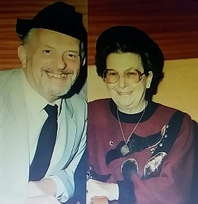

My father, Abba haCohen (Albert (Cass, was born in 1921 in the town of Llanelli in South Wales. Jewish life and education in the UK during the 1920's and 30's was remotely distant from that of nowadays. Each community was small and isolated. There was no Chabad movement in the country to assist Jews in times of need and the Jewish London of those days was far removed from the Golders Green and Stamford Hill that we know today.
At the outbreak of the 2nd World War in 1939, the authorities posted my father to work in a factory in London making instrumentation panels for airplanes. He had trained as a jeweler and this work was not greatly different from repairing and making clocks and watches. It was certainly a better offer than being drafted into the armed forces. Life in the armed forces was not easy for any one. Paradoxically, despite the fact that England was fighting the accursed Nazis; anti-Semitism was rife in the British army and little was done to help Jewish soldiers keep the faith.
His mother imbibed in him a genuine affection for yiddishkeit (Judaism) from a young age. It was quite natural that when leaving Llanelli he took with him his tzitit, tefillin, a siddur, and a Chumash. He hoped that despite the ongoing hostilities and the blitz on London he would still be able to keep as many mitzvot as possible. However, London was far removed from Llanelli both geographically and spiritually.
His living quarters and work site were distant from the Jewish areas of London. He had no contact with Jewish people and was informed by his superiors, in no uncertain terms, that England was at war. The factory was open seven days a week and failure to work on Shabbat was an offense. The loss of his job would mean being drafted to the front lines. For the first time in his life, he was unable to keep Shabbat.
When the war was finally over, a cousin, serving as a Rabbi of a small community, near London, introduced him to my mother. Mother had been brought up with much Jewish awareness but without any formal Jewish Education. After the wedding, they settled in Llanelli for a short period. Mother learned much about Judaism while living there, but lacking a livelihood, the young couple moved to my mother's hometown.
My grandfather gave father a section of the family store where my father opened a jewelry division. My father wanted to close his department on Shabbat but was told quite clearly that this was "impossible". Business takes place on Saturday. "Better to close 6 days a week, so long as you work on "Saturday" was a phrase that he and many other young Jews heard in those days.
He loathed having to work on Shabbat but always hoped that one day the situation would change. As a "second best", he organized his work breaks to fit in with Shul attendance on Friday night and/or Shabbat morning whenever he could.
After some years, my parents moved to a different town, with no Jewish population, to open their own business. Over the years that followed, he often tried in thought or deed to close his business on Shabbat, but the old mantra overpowered his good resolutions.
During our childhood, we siblings were encouraged to practice yiddishkeit as much as possible. As my brother and I were older, it became the custom in our family that we would run the business for 3 weeks every summer holiday. This gave my parents a well-deserved annual vacation. We brothers were, by now, fully Shabbat-observant, thus for three Shabbatot every year the business was closed.
Time moved on, my brother married while I decided to go to yeshiva, before settling down in my chosen profession.* I went to learn in Kfar Chabad under the tutelage of HaRav S.Z. Gafni. At the end of that year I made my very first visit to the Lubavitcher Rebbe at his court in the famous '770.' On the way there, I made a stop in England for three weeks to allow my parents to take their time-honored holiday.
My first action in the store was to prepare a notice announcing that the shop would be closed on Shabbat. This put me in a dilemma. As much as I wanted, I had no authority to assert that the store would now be closed every Shabbat. Similarly, I had no desire to write that it would be closed only on this Shabbat. I searched for a suitable compromise. Utilizing the vagaries of the English language, I printed, "This shop will be closed all day Saturday."
After, two weeks my parents came home unexpectedly, they had decided to cut their holiday short, thinking that it was inappropriate for ayeshiva boy to be working in a business instead of learning in Yeshiva. As the weekend approached, my father decided to keep the status quo. There would be no change in the family tradition of many years and the third Shabbat was honored as usual. The notice remained in place and my parents went to London to spend a happy family Shabbat.

OPEN AND REVEALED MIRACLES
In the UK, in those years, businesses were closed on Sunday and reopened on Monday morning. Accordingly, on the following Monday morning the doors of my parents' shop were duly opened at 9:00 a.m. Lo and behold, after no more than 10 minutes a large tourist coach pulled up outside the store. Over 50 visiting tourists entered and started to buy everything that the eye could see. Money was flowing like the water in Niagara Falls. Somewhat taken aback, my father asked one of the people, "Where are you from? Who are you? What is going on?"
They explained that they lived about 400 kilometers away from the shop and they were a group of friends who occasionally traveled to see different parts of the U.K.; always on a Saturday. They came to the town two days previously, fell in love with the shop from the outside but were bitterly disappointed that they could not enter. They had therefore they hired another bus and returned on that remarkable Monday morning; spending money like it was going out of style.
At the end of the week, on Friday morning my parents realized that, remarkably, their weekly takings thus far, was more, much more, than in an average week. My father concluded that the Creator was very happy that the shop had been closed on the previous Shabbat. Leaving the notice firmly attached to the door they decided to leave the shop closed for the upcoming Shabbat. So, Friday afternoon saw my parents drive home to London and keep another Shabbat. The miracle repeated itself week after week less working hours with a larger turnover!
During the month of Elul, the final month of the Jewish year, I was in 770 basking in its unique atmosphere of holiness. Nevertheless, I received regular reports about my notice. My father said that it was as if G-d had picked up the pavement and people were sliding into the shop and spending their money at the behest of a higher force.
The next test came quickly for Rosh Hashanah was approaching. Yom Tov was Thursday and Friday. My parents left the shop on Wednesday afternoon and did not return until five days later. This meant that the shop was only open for half of that week yet their income did not waver at all. Yom Kippur, the first two days of Succot, Shmini Azeret and Simchat Torah came and went. The notice stayed bonded in place and the Al-mighty took care of their income.

THE YETZER HARA'S LAST ATTEMPT
Those brought up in Western countries, may remember there is a time of the year when the local population goes completely wild, buying presents for their end of the year annual holiday. The day before the holiday is the busiest shopping day in the whole of the UK. The day before not much less.
Businesses relied on the time to carry them through, financially, for a large part of the year. Looking at the calendar, my father noticed that this amazingly profitable day fell out that year on no less a day than Shabbat. The day before, Friday, Shabbat started at 3pm. London was 2 hours' drive away. Both days were "lost".
The Yetzer Hara ('evil inclination') persuaded him that G-d no longer loved him; otherwise, this could not have happened. "You just cannot afford to close your shop for two such busy and profitable days." Inexplicably my father pulled the notice off the door.
This was a Monday morning. That Monday not a single customer came into the shop. The next day Tuesday the notice was still down and again no customers came in. On the Wednesday, my mother who did not speak very much and always kept her thoughts to herself, looked at my father in the eyes and said, "Put back the notice or else you will destroy your neshama (divine soul)."
The word 'neshama' was not part of her known vocabulary. Somewhat taken aback by this bold statement, my father without as much as a word replaced the notice on the door. Within a matter of minutes, customers poured into the shop from every conceivable direction. The miracle had restarted. It goes without saying that the shop was never open again on a Shabbat and the notice stayed in place until the day the business was sold.

FRIDAY STREET
After Chanukah, I became engaged. I brought my kallah (bride [to-be]) to see the shop and our apartment above it. The shop was mostly on a main street, but continued around the corner along the side street. My family had only ever used the name of the main street for the store's address. However, the main window of the apartment faced the side street.
The first time my kallah looked out the window, she was immediately confronted by the bold street sign facing the window: FRIDAY STREET. She turned to my father and asked him if he had ever noticed the name of the street. He smiled and said, "Yes of course. It's there to remind me to go home for Shabbat!"

*Source: Submitted by Yaakov Cass. Cass, a Lubavitcher chasid, is a former District Pharmacist of the Israel Ministry of Health.
Editor's note: A shorter version of this article appeared in Living Jewish several weeks ago. The above is the full version, as requested of me by the author.

Reprinted from the Parashat Va’etchanan 5779 email of KabbalaOnline.org, a project of Ascent of Safed. www.ascentofsafed.com ascent@ascentofsafed.com

The Wife Who Wanted
To Donate Her Kidney

The following story is an example of mesirus nefesh for the mitzvah ahavas Yisrael, and the benefits that were earned from it. I heard the story directly from the baal hamaasah, who is a respected rav in America, and is also involved in kiruv rechokim.
One day his wife told him she wants to donate a kidney to someone suffering from kidney disease and is undergoing dialysis. Her husband was against the idea, but she insisted that she wanted this zechus. So they went to the Skverer Rebbe shlita and sought his counsel.
The Rebbe told the husband to respect his wife's wishes because it is a great mitzvah to save a life.
The husband asked, "When should she have the operation? I know the ill patient needs the kidney as soon as possible, but our child's chasunah is coming up…"
The husband wanted to push off the procedure until after the chasunah. His wife, however, had rachmanus on the person suffering and wanted to have it done before the chasunah.

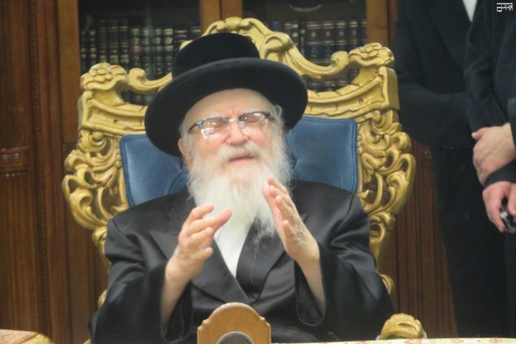
The Skverer Rebbe, shlita (Rabbi Dovid Twersky)

The Rebbe told them to discuss it with the doctor. If he says she will be better in time for the chasunah, she can go ahead with the procedure. They consulted with the doctor, and he agreed to speed up the prep stages, and do the transplant as quickly as possible so the mother can recuperate in time for her child's chasunah.
Kidney donors undergo a series of tests to verify they are healthy candidates and their organs are suitable for transplanting. The doctors began taking the standard battery of tests, and the doctors discovered she had a growth right beneath one of her kidneys.
The growth was pressing on a primary artery that sends blood to the heart. If they wouldn’t have done those tests, it is likely the growth would eventually block the blood flow to her heart and her life would be in danger. It is doubtful she would have lived to see her child's wedding. Because of her ahavas Yisrael her life was saved. (She was disqualified as a donor. However, just then another compatible donor was found, so the patient had the transplant, as originally planned.)

Reprinted from the Parshas Devorim 5779 email of Torah Wellspring: Collected Thoughts from Rav Elimelech Biderman.

The Ne’ilah Machlokes

Reb Y. Kletzky of Yerushalayim goes to America each year to serve as a chazan for the yomim nora’im. One year, there was a machlokes between the gabai and one of the mispalelim (in the beis knesses where Reb Kletzky was chazan), and despite people’s attempts to make peace between them, no one succeeded. This man (who was in the machlokes) had two older, single children, around thirty-years-old. Every year he bought the honor of לנעילה הארון פתיחת ,opening the aron kodesh for Ne’ilah, and he with his two sons would stand in front of the aron kodesh throughout Ne’ilah, hoping that the gates of heaven would open for them. He paid whatever price necessary, to buy this merit. However, this year, because of the machlokes, the gabai didn’t want to sell it to him. What did the gabai do? He gathered his friends before Rosh Hashanah, and sold all the aliyos and kibudim of Rosh Hashanah and Yom Kippur.
When it was time for opening the aron for Ne’ilah, it was already sold to someone else. When Reb Kletzky, the chazan, began the quiet shemonah Esei of Ne’ilah, this man began to speak loudly, complaining that he was slighted and tricked, and his chazakah (yearly custom) was taken away from him.
Reb Kletzky says he wanted to calm him, and to speak up in his honor, but he was already in the middle of the amidah. After Yom Kippur, Reb Kletzky came to his home and said, “As chazan, I'm responsible that the tefillos of the beis knesses go up. But due to what happened today, I'm afraid the tefillos didn’t go up. I beg you, forgive him.”
The man didn’t forgive, and he said that he doesn’t forgive the entire beis knesses, because none of them stood up for him. Reb Kletzky found a solution. He said, “The primary reason you want to open the aron for Ne’ilah is because you want shidduchim for your two children. Be mevater. Forgive them. In this merit, by next year, they will both be married.”
“I forgive them” the man exclaimed.
Later that year, Reb Kletzky called the gabai and asked what happened with that person. The gabai replied, “He stopped coming to our shul long ago. However, I heard that in the winter both of his children were married…” This is the reward for those who forgive and seek peace.

Reprinted from the Parshas Devorim 5779 email of Torah Wellspring: Collected Thoughts from Rav Elimelech Biderman.

Reuven Bauman:

Through Fire and Water
By Rabbi Shraga Simmons
Photo Credit: Bauman Family
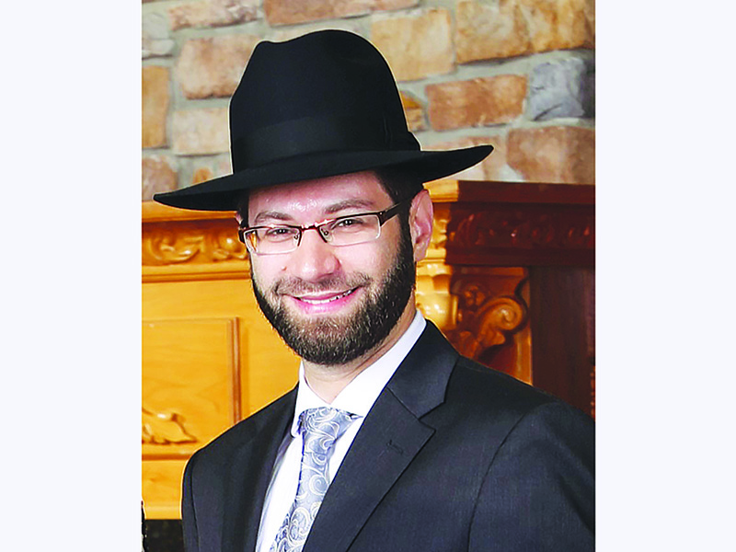

The story is well-known: On July 9, 35-year-old Rabbi Reuven Bauman was on a Virginia beach, chaperoning day campers. Some of the boys got too close to the water’s choppy edge and were caught off-guard by a giant wave. Seeing the boys struggle to regain their balance in the now-deep water, Reuven immediately threw off his shoes and rushed in to save them.
During those perilous moments, Reuven held the boys tightly, keeping them from slipping out further. A nearby fisherman helped the boys reach shore safely. Yet suddenly, Reuven himself was caught in a treacherous rip tide and swept out to sea; his body was recovered five days later.
From where did Reuven derive this extraordinary sense of courage and self-sacrifice for others?
After speaking with the Bauman family, the rest of the story can now be told.
New York City, 1967. Reuven’s paternal grandfather, Wilhelm Bauman (known fondly as Willy), was a cabinet-maker. While out on a job, Willy’s partner was working in an adjacent room. Suddenly Willy heard a massive explosion. Highly-flammable glue had combusted – consuming the adjacent room in flames.
Disregarding his personal safety, Willy rushed into the dangerous inferno and pulled out his injured partner – likely saving the man’s life.
In the process, however, Willy was critically injured with third-degree burns covering much of his body. Doctors did not expect him to live through the night.
Willy stayed in intensive care for many months, and eventually – with the help of an experimental burn unit – returned home to his family. Though his ability to walk was permanently damaged (he often used a wheelchair), Willy lived another 40 productive years.
Rabbi Mark Bauman was 12 years old when his father performed this exceptional deed. Mark is also the father of Reuven Bauman, whose valiant rescue on a Virginia beach echoes his grandfather’s lifesaving deed of 50 years earlier.
“Between my father and my son,” Mark says of the heroic courage transmitted through generations, “it was fire and water.”

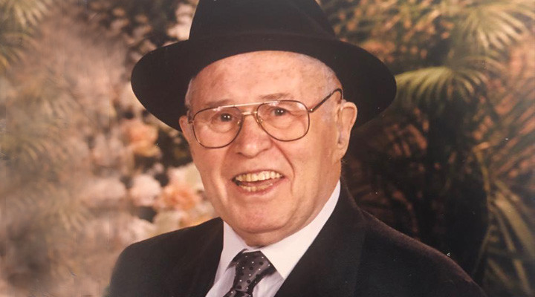
At great personal cost, Willy Bauman performed a heroic lifesaving rescue in 1967.

Appreciating Reuven
Reuven Bauman was a beloved teacher of children in Norfolk, Virginia, spending countless hours meticulously preparing class material and developing new methods to teach in a clear, accessible way.
On a personal basis, Reuven was devoted to his students, caring and connecting to each on his level. “The boys loved him,” says Reuven’s father. “The other day a parent came over to me and said: ‘My son dislikes school, but he loved Rabbi Bauman’.”
Two days before his death, Reuven accompanied the day camp to an amusement park. He rode on terrifying rollercoasters, feeling it was important to share that experience with the kids. “His commitment to his students was his life’s mission,” said Rabbi Mordechai Loiterman, the principal where Reuven taught. “It wasn’t a job he was doing; this is how he defined himself.”

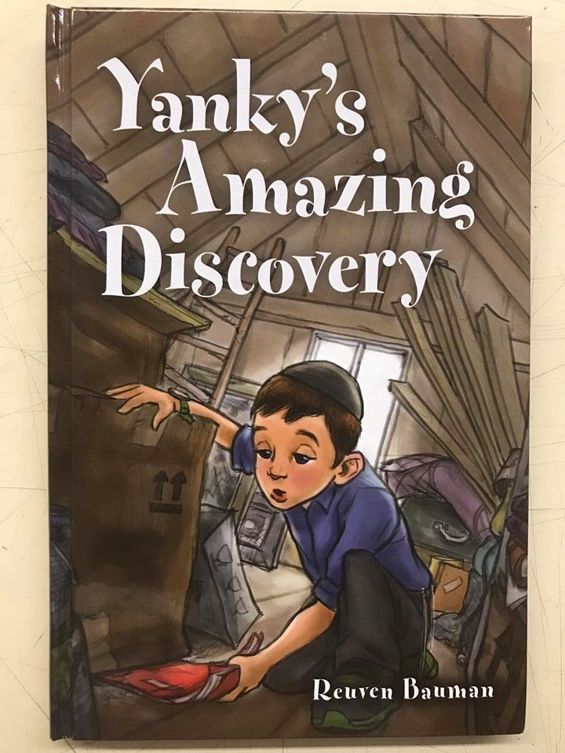

Last year, Reuven published a children’s book, Yanky’s Amazing Discovery, about a boy who overcomes his struggles. The boy is inspired by Rabbi Yaakov Kamenetsky, one of the greatest rabbis of the 20th century, whose character traits could be emulated by a child on any level.
Says Rabbi Mark Bauman: “Reuven felt it was important to portray our Sages in a way that is relevant and accessible, to encourage young people to aspire to their greatness.”
Reuven also wrote children’s poems about the Jewish holidays, which is being prepared for posthumous publication.
Family and friends describe Reuven as the perfect blend of intellect, humility, dignity, sweetness, humor, and love. Regardless of age, level of observance or background, Reuven respected everyone. When the yeshiva’s non-Jewish cook had a heart attack, Reuven took the initiative to buy a card, have everyone sign it, and bring it to the hospital.
“He always made you feel like a ‘somebody’,” says Yisrael Schwartz, Reuven’s brother-in-law. “His kindness, his smile, his ability to connect with people. Reuven had a quiet, gentle way of making you feel good about yourself.”
Reuven lived and died with Kiddush Hashem – deeds that sanctify God’s Name. His jumping into the dangerous waters to save his students was but an extension of his devotion to always putting others first.
Mordechai Bauman, one of Reuven’s five brothers, cites theTalmudic teaching that if someone desecrates G-d’s Name in secret, the deed is exposed in public. The same is true of the flipside: If a person sanctifies God’s Name in secret, the deed is rewarded publicly.
“Throughout Reuven’s life, he sanctified God’s Name in a very quiet, unassuming manner,” says Mordechai. “Maybe that is why G-d gave him the opportunity to complete his mission with an act that would cause a public Kiddush Hashem, one which spread across the globe.”

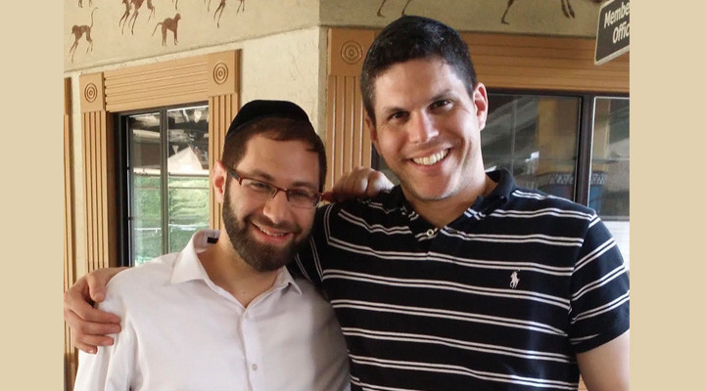
Reuven with his brother-in-law, Yisrael M. Schwartz

Massive Recovery Effort
When Reuven went missing, people far and wide were amazed at the massive outpouring of assistance, as hundreds of volunteers from organizations in New York, New Jersey, Maryland, and Georgia rushed to Virginia to join the search. Helicopters and a private airplane were commandeered to search up and down the coast; others came with boats and jet skis. Volunteers in SUVs scanned the terrain with binoculars, while other crews walked miles along the shore in 90-degree heat.
“When the call goes out that someone needs help, you just go without thinking twice,” says Yosef Nissel of Misaskim of Maryland, an organization that helps those dealing with tragedy. Nissel and his team of volunteers drove four hours to Virginia Beach with a boat in tow; upon arrival they chartered a second.
After a day or so of searching, the Coast Guard and other public rescue teams ended their effort, conceding it as futile. Yet the army of Jewish volunteers would not be deterred. Driven by the ever-slim chance of rescuing Reuven they pressed on, committed not to leave until they could at least accord Reuven the honor of a proper burial.

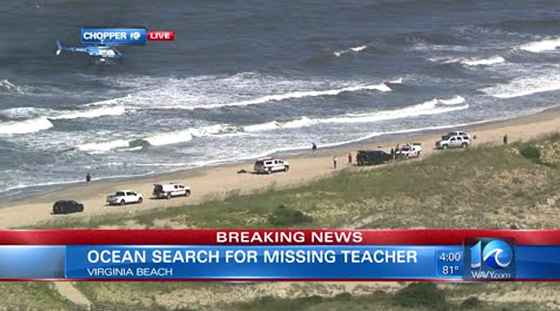

Day after day, working for hours on almost no sleep in sweltering heat, volunteers combed 450 square miles in a coordinated and organized effort. They were assisted by a local expert who calculated tides, currents and wind patterns – devising search grids for land, sea and air.
Meanwhile, thousands around the globe were drawn to this tremendous Kiddush Hashem by praying and performing good deeds on behalf of Reuven.
After a break for Shabbat, the volunteers were back in the ocean Sunday morning before sunrise.
On Sunday, as the midday sun beat upon the exhausted crew, a local fishing captain suggested that volunteers head out a few miles to where the ocean turns clear and has thick patches of seaweed. There, about one mile off the coast near the Virginia-North Carolina border, and six miles from where Reuven was last seen, Nissel’s team spotted his body.



For an entire week, volunteer organizations like Achiezer, Misaskim, Chai Lifeline, Chaverim and Hatzalah were featured on the news – highlighting the tight-knit Jewish community and making a positive impression on everyone involved.
Coast Guard members were especially inspired, given that a few weeks earlier an 8-year-old boy had drowned in similar circumstances, swept away by a powerful rip current. In that instance, authorities gave up the search and simply waited for the body to wash up on shore.
In one particularly dramatic moment, when the Coast Guard diver brought Reuven’s body out of the water, he proudly declared, “I am a Jew.”
Importantly, Reuven received a proper burial, bringing a measure of relief to the grieving family.
Via conference call, over 40,000 people attended the funeral, where his brother-in-law Yisrael Schwartz declared:
“It as if G-d was saying to Reuven: You’ve done all this kindness for others in your quiet, unassuming way. Now I will give you a chance to save a life, and make a tremendous public Kiddush Hashem. The name Reuven Bauman will be known around the world as a man of true Kiddush Hashem. Here you go, Reuven. Take this gift. You deserve it.”
For Reuven Bauman, other people always came first. Now we each have the opportunity to give something back, by helping to care for Reuven’s wife and five young children, with a donation to the Bauman Family Fund.
On this his shloshim, may the memory of Reuven Tzvi ben Menachem Yitzchak continue to uplift and inspire.

Reprinted from the August 8, 2018 email of The Jewish Press. Originally printed on the Aish.com website.

The Airport Minyan

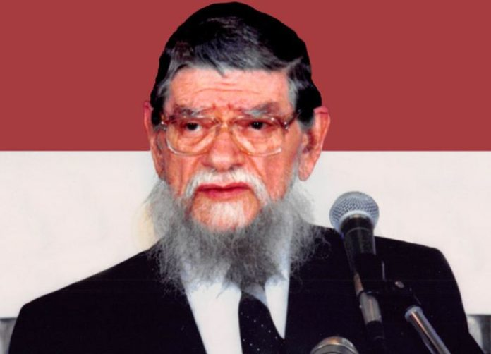

One time, Rabbi Mordechai Gifter, O”BM, went by plane, together with a number of students, to a wedding in Baltimore. Due to the weather conditions in one of the connecting cities, their flight was subject to a number of delays.
After a while, Rav Gifter realized that regardless of the connection, they will not make it to the wedding on time. They decided that before they return to Cleveland, they would pray Minchah (the afternoon service), as it was getting dark. Praying in a private room is preferable to praying in the middle of the concourse. Thus, they sought out a maintenance man to provide a room for them. They “luckily” located one who immediately proceeded to open a room for them. The “airport Minyan” prayed Minchah, and as they were about to leave, the maintenance man came to the door and asked one of the young men to help him recite Kaddish (a prayer for a deceased person, in order to elevate that person’s soul).
Upon hearing this, Rav Gifter approached the man and questioned him regarding his background.
The man related the following story: “My father was an assimilated Jew and I, as you can see, am totally estranged from Judaism. My father passed away just a week ago. Last night, he appeared to me in a dream and said, ‘Say Kaddish for me!”
“I looked up at my father and asked, how can I say Kaddish – I never went to Hebrew school. You never taught me how to read. Plus, I have no idea where to go to find a Minyan!’
“My father replied: “don’t worry, I will provide you with a Minyan.’ You are the Minyan that my father sent for me!”
After they said their goodbyes to the man, with the promise to follow up on their newly-developing relationship, Rav Gifter turned to his students and remarked, “We thought we were traveling to Baltimore for a wedding. In truth, we were traveling to this airport to provide a distinguished Minyan for this man, so that he could say Kaddish for his father and honor his father’s wishes.” (Story from Rabbi A.L. Scheinbaum)

Reprinted from the Parshas Devorim 5779 email of Torah Sweets Weekly edited by Mendel Berlin.

The Dirty and Beaten-Up
Car that was Up for Sale

In Hollywood, Florida lived a couple Dr. and Mrs. Rosenblatt. Dr. Joe Rosenblatt was a top oncologist in the country, and one day, his wife, Lilly was driving on I-95. Two lanes away from her was a car for sale. It was a beaten-up pile of metal and the car was so dirty, that the owner wrote “For Sale, Call…” in the dirt.
She picked up her phone and called the number on the car. Dr. and Mrs. Rosenblatt had new cars and had no need for a car like that. She always said she never knew why she called, but she did.
The number picked up, and out of the blue, Lilly Rosenblatt said, “I’m driving two lanes away from you. Why are you selling your car?”
The man in the car could have responded in a number of ways to such a strange question. However, he started to cry and tell his story. “My young wife and I are from South America, we got married only a few years ago. Everything seemed perfect. We just moved to Florida, and upon moving here, unfortunately my wife was diagnosed with a terrible illness.


Dr. Joseph D. Rosenblatt

“We don’t have any insurance. But every doctor we visit tells us the same thing.‘The only oncologist who has a chance of saving your wife is Dr. Joe Rosenblatt.’ So we are selling our car to be able to afford to see him.”
Lilly understood now why she was guided by Hashem to call. Calmly, she said, “Joe is my husband. Save your car, go pick up your wife. I will call him. Drive to Sylvester Center in the University of Miami and he will take her on as a patient, free of charge.”
And as a messenger of Hashem, the One who is truly in control and running the world, Dr. Joe Rosenblatt saved the life of this young woman and made an amazing kiddush Hashem!

Reprinted from the Parashat Mattos-Massei 5779 emil of Rabbi Amnan Sananes as written by Jack E. Rahmey.

